|  |  |
| --- | --- |
| **Title** | 2nd homework in the Electric Circuit Theory class by 201923250 |

|  |  |  |  |
| --- | --- | --- | --- |
| **Author** | 201923250 | **Date** | 9.10.2020 |

**Summarization for sections 7.5 to 7.7**

We must digress before we continue with the second half of this segment. And take certain mathematical principles into account, which will help us understand transient analysis. A profound concept of singularity functionality can help us understand the first-order circuit response apply a single DC voltage or current source unexpectedly. Singularity features are very useful in circuit analysis (also called switching features). The signal switches in circuits that are associated with switching operations are used as good approximations.

In electrical circuits, pulsating currents and voltages occur switching or impulsive origins activities. The role can not be done (as ideal sources). It's a very handy mathematical instrument, resistors, etc. If an RC circuit dc supply is applied unexpectedly, the voltage is used

as phase function, and answer, the current source can be modelled it is known as the Schritt Antwort.

**Example problems**

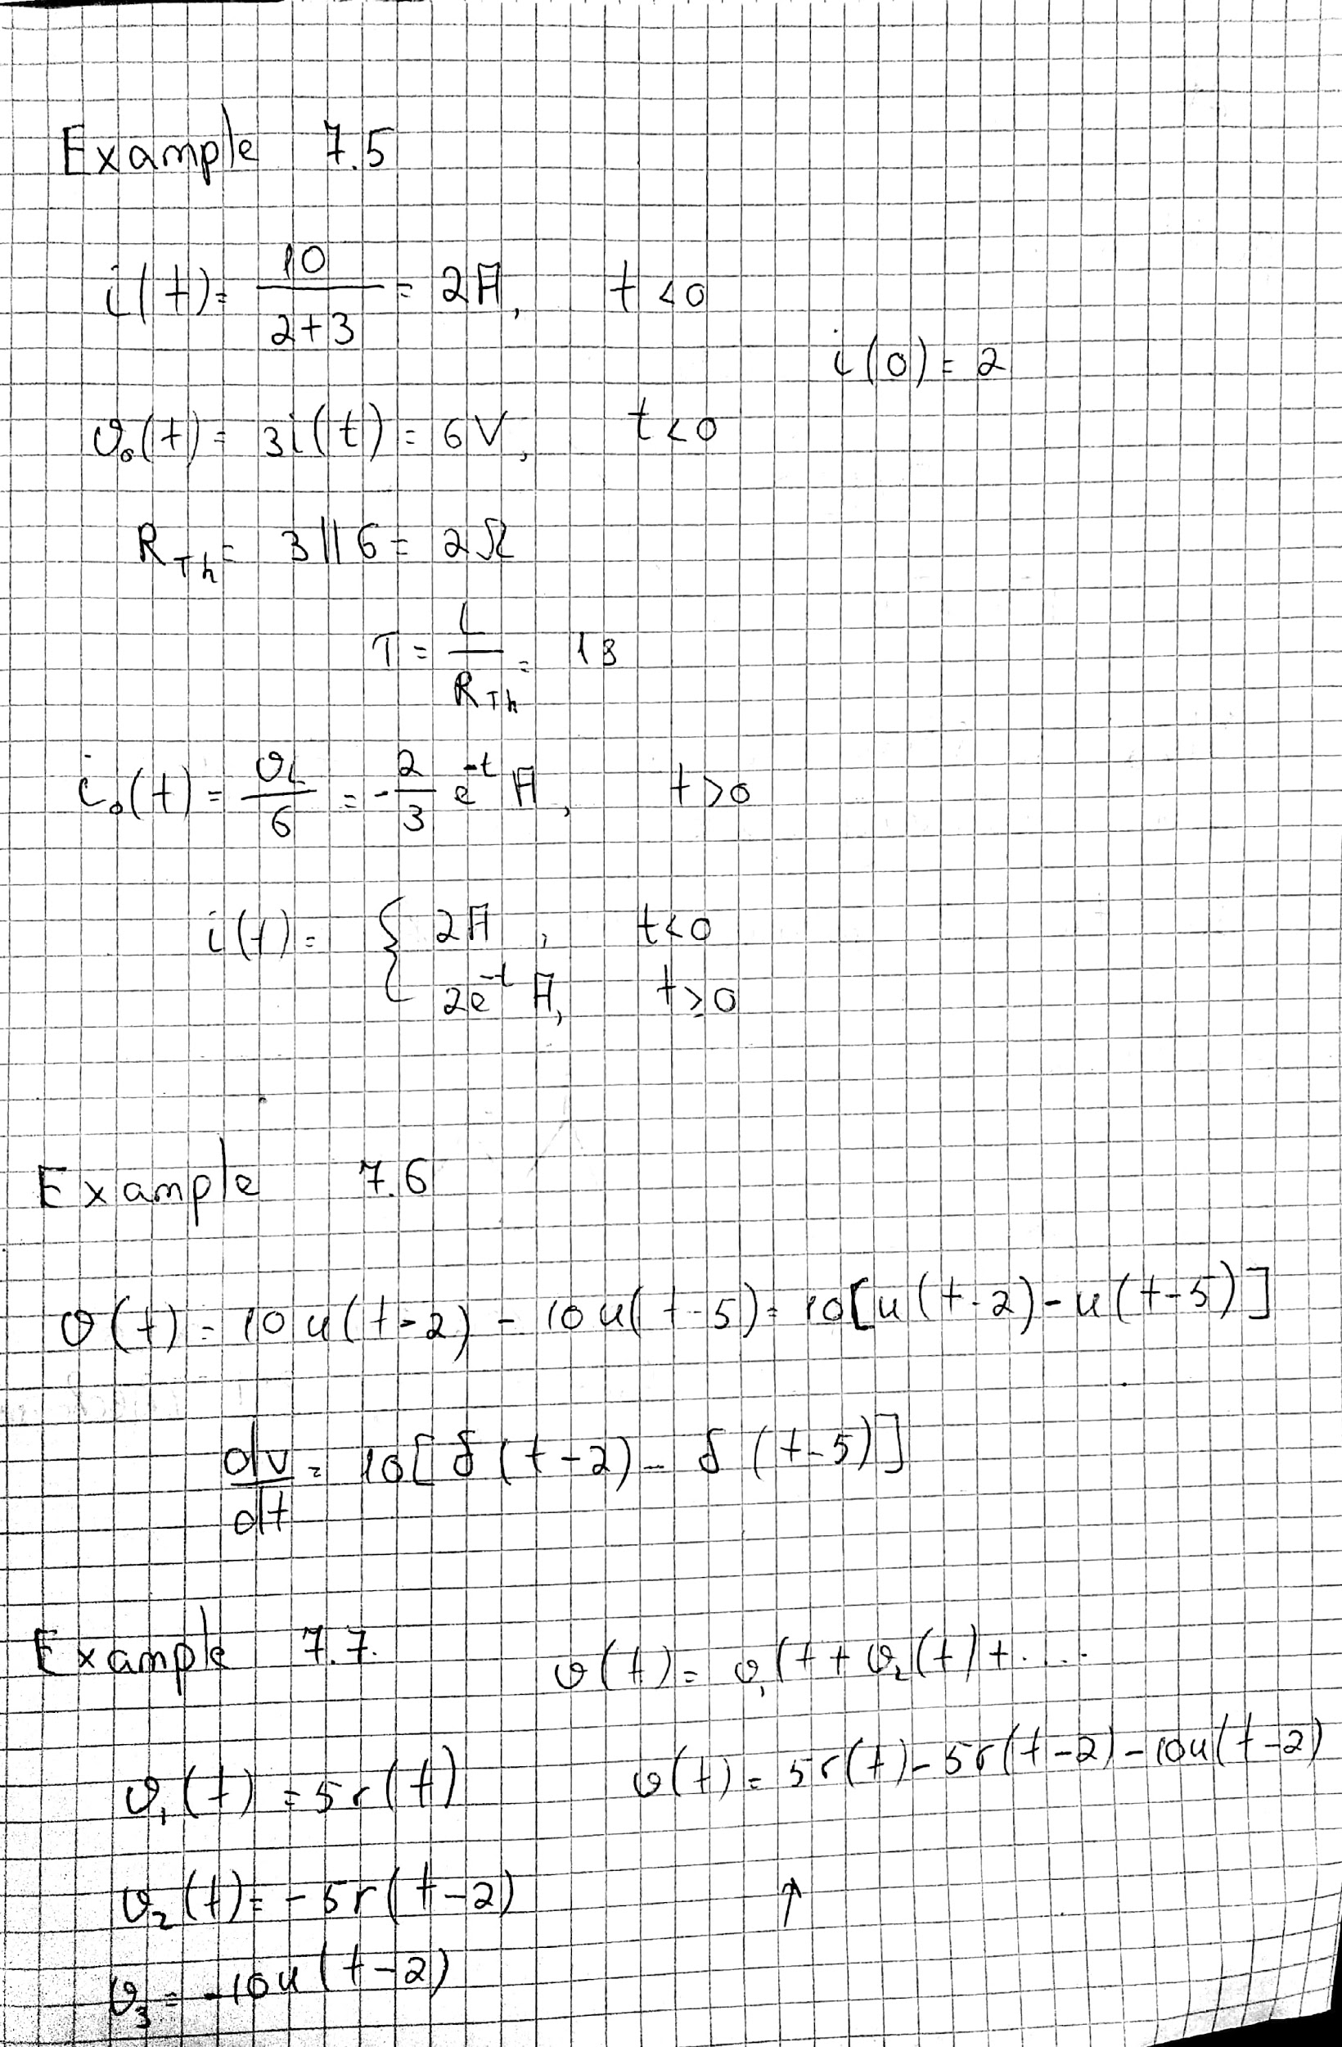



Student ID : 201923250

Name : Kobilov Ilkhomjon